Obarinky Cookies (Тістечка Обарінки)
Lada Onyshkevych
From my Teta Baba’s recipe collection. Attributed to Ika Melnyk. With some modifications.
The dough is crisp, like крухі тістечка. There is a very delicate lemon flavor (you may wish to punch up the flavor with some almond or vanilla extract).
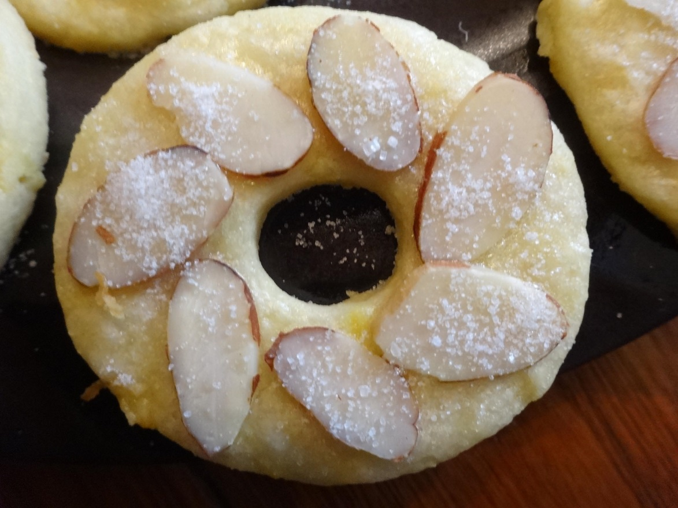

Dough ingredients:
12 dkg. Flour (about 1 c.)
1 egg yolk, cooked
8 dkg. Butter (5 ½ Tbsp), softened
4 dkg. Sugar (less than ¼ c.)
Zest from 1 lemon
(Optional, for more flavor: ¼-1/2 tsp. almond or vanilla extract)

Topping:
1 egg white
Coarse sugar
Almonds (sliced, slivered, or chopped)

Directions:
To cook the egg yolk, separate the egg, save the egg white for the topping, slide the egg yolk into simmering water for about 2 minutes until cooked; you can press the cooked yolk through a sieve, or just put it in the mixing bowl with the other ingredients – it won’t be quite as evenly distributed, but will work just fine.
Mix flour, egg yolk, softened butter, sugar, lemon zest, and almond extract. Mix into a smooth dough.
Wrap dough in plastic wrap and chill for about an hour.
Preheat oven to 350F.
Roll out dough about 1/8-1/4 inch thick. Dough should be easy to work with. Reroll scraps and continue cutting out cookies until no dough is left.
Cut out doughnut-shaped cookies. (I used Wilton’s Round Cutter set, but a linzer cookie cutter would work well too).
Line a baking sheet with parchment paper.
Place cookies onto lined baking sheet. They don’t spread much at all, so you can position them fairly close together.
Use a pastry brush or other tool to give the cookie tops an egg-white wash.
Immediately place almonds on cookie surface as desired (for sliced almonds, you can do a wreath design; for slivered almonds, you could do a flower pattern).
Sprinkle cookie surface heavily with the coarse sugar. (if using chopped almonds, you can mix them with the sugar at about a 1:1 ratio before sprinkling).
Bake at 350F for 10 min.
Cool briefly, remove to plate.
Cookies taste better the next day.

Other Obarinky recipes from my Teta Baba’s collection:
-sour cream version: ¼ c. sour cream, ¼ c. softened butter, ¾ c. flour; Mix, chill overnight, proceed as above
-yeast version: 3 egg yolks, 2 Tbsp. sour cream, 1 Tbsp. softened butter, 1 packet yeast, ¾ c. flour; mix and proceed as above

